## Overview From wikipedia

* Wholesale energy market for spot prices: Energy generators and energy retailers (plus some large industries) can sell and buy electricity at 200 locations throughout New Zealand every half-hour. The market takes generators offers and retailers bids and calculates the price based on this.
* In addition to the wholesale market there are two other markets: a hedge market for CFD contracts and a financial transmission rights (FDR) market operated by a unit of trans-power. These markets (somehow) are tied to the wholesale energy market and allow suppliers to manage their risk.
* Trans-power predicts prices to help generators make offers and is also responsible for matching supply and demand in real time. Trans-power takes the lowest cost combination of offers from the generators to match demand.
* There are five major generators, contact, meridian, mercury, trust power and Genesis.
* The New Zealand electricity market Wikipedia page has data on electricity spot price which I could look to download. They also suggest examples of factors influencing spot prices: seasonality, with lower demand in summer, and rainfall influencing hydro dam levels. Note from the below plot that hydro is over 50% of all energy, but in the South Island it’s 98%. So South Island droughts could massively affect South Island prices.

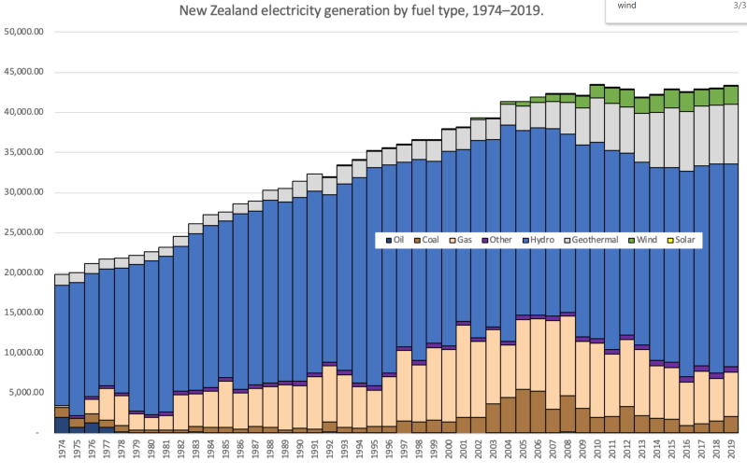

* Meep

## FTR market from ea.govt.nz

* **Financial Transmission Rights are contracts that give the owner the right to the difference in price between two hubs, reducing locational price risk**. Because electricity prices can differ in unpredictable ways between locations. Useful for two reasons:
* allows retailer/generators to manage risk when selling electricity in one location and buying in another. Example: a retailer/generator can sell electricity for $130 in Invercargill but has to buy electricity for $145 in Christchurch. An FTR contract for these locations would pay out $15 at this time - so for the cost of the FTR (think insurance premium, but bought at an auction) the retailer/generator can essentially pay the Invercargill price in both locations.
* allows retailers holding traditional hedge products (ASX hedges and contracts for difference) to tie the price to pay for their electricity to the value of a hedge they hold in one location (*don’t understand this one and think the previous example is more important anyway*). Example: a retailer could use an FTR to ensure the price they pay in Invercargill depends on the value of a hedge they hold in Christchurch. Actually this is what jon says haast mainly does

## Hedge market on ASX

Believe this is just a CFD (contract for difference) market, identical to the FTR market? **Although perhaps over time rather than location**. So you can hedge against price changes, e.g. say current price is $100 and price in 1mo is $150, for the cost of your CFD you could essentially pay $100 for your electricity in a month. In this case the buyer benefits. For sellers, you may want a CFD to hedge against price drops. E.g. price drops from $100 to $50, but you could cancel this out with a CFD.

## Electric kiwi

* started in 2014 with three entrepreneurs with IT and electricity expertise.
* Made use of new smart meters that were rolled out across the country, which no one else had done. Allowed things like the hour of power.
* Everything is online, which benefits consumers
* has won lots of awards and is the fastest-growing electricity provider in New Zealand